- Bar Plot – Compare amounts across categories

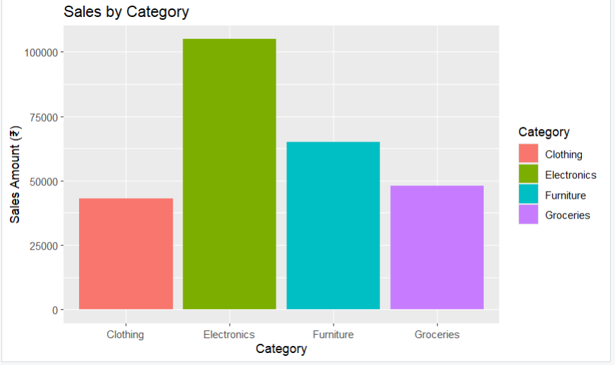

2. Grouped Bar Plot – Category vs Month
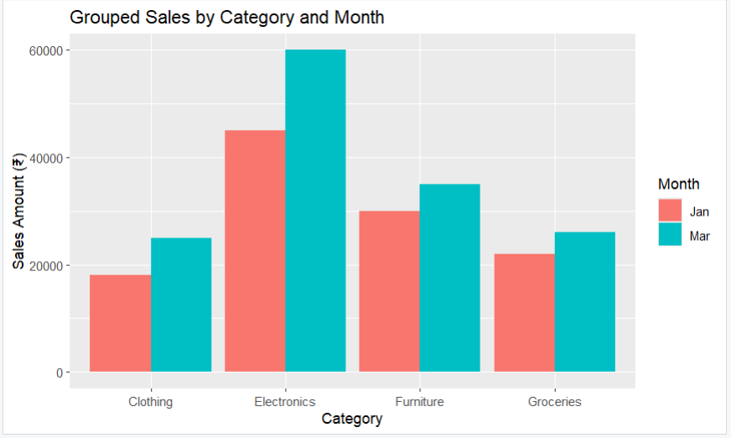

3. Stacked Bar Plot – Part-to-Whole
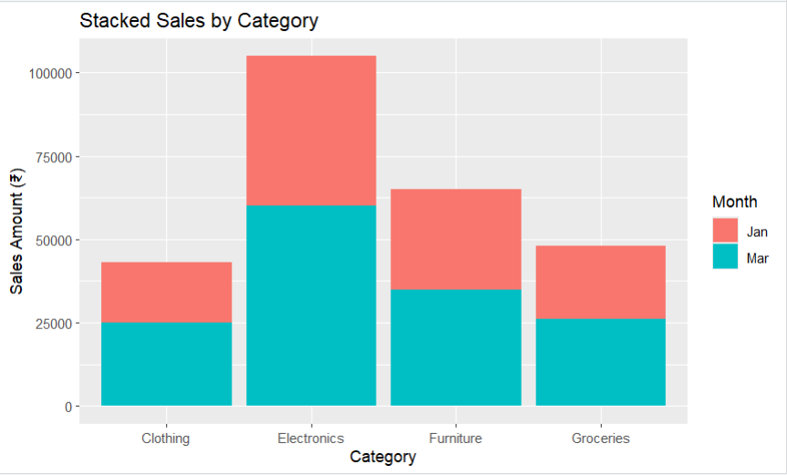

4. Dot Plot – Category Comparison
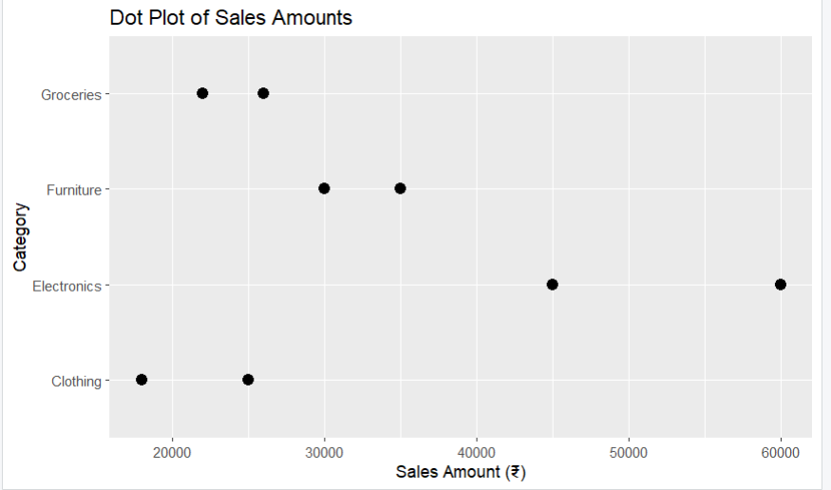
5. Heatmap – Category vs Month
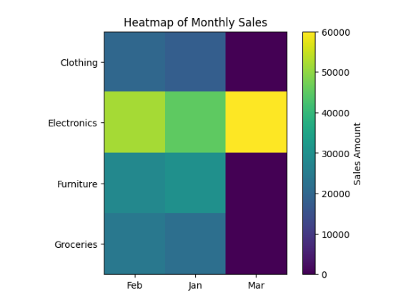

6. Violin Plot – Sales Distribution by Category
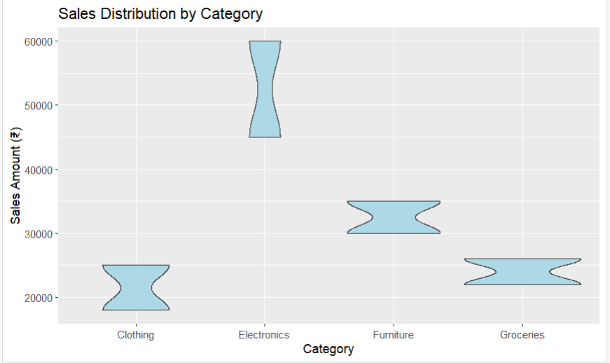
7. Ridgeline Plot – Distribution Comparison
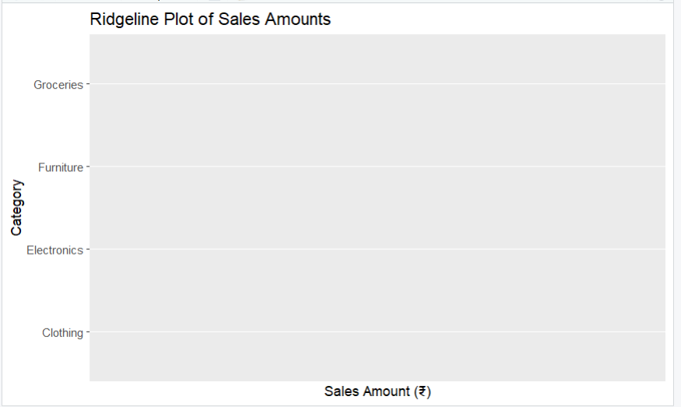

8. Histogram – Sales Amount Frequency
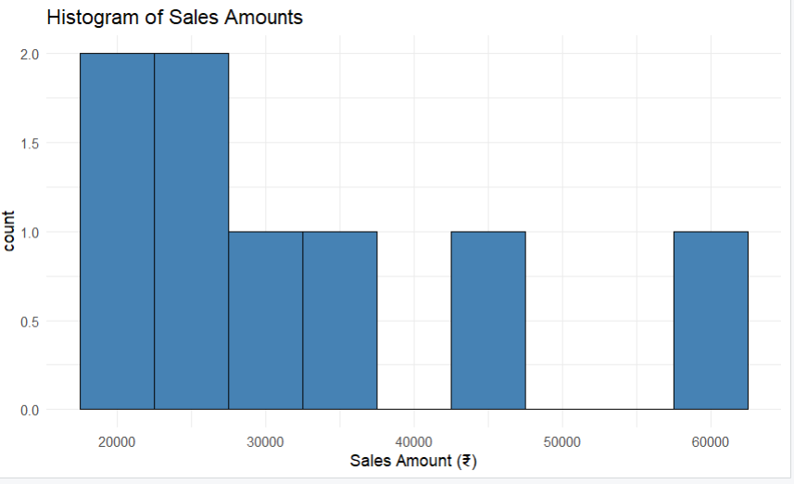

9. Density Plot – Smoothed Distribution
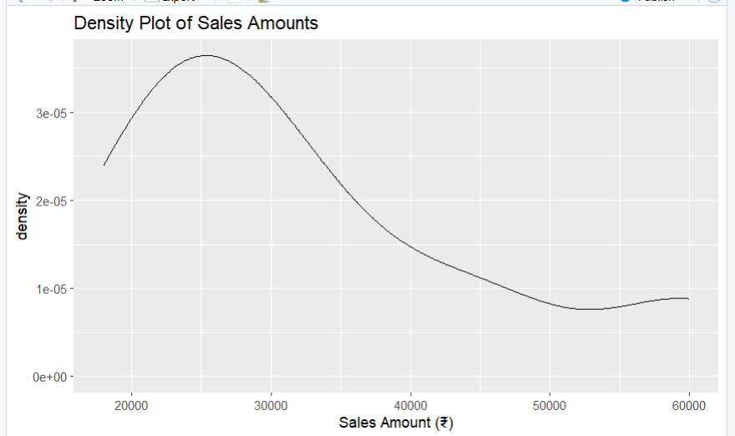

10. Boxplot – Summary Statistics
